Item 5.1 Mayoral Minute - Superintendent Christine McDonald - Irene Juergens APM Fellowship Award

**Attachments: Nil**

Submitted by: Councillor Michael Megna (Mayor)

|  |
| --- |
| Motion  That Council receive and note the report |

Background

I am pleased to recognise and congratulate Superintendent Christine McDonald, Burwood Local Area Commander, for receiving the Irene Juergens APM Fellowship Award at the Rotary Clubs of NSW Police Officer of the Year Awards 2024.

This award acknowledges individuals who show dedication to community-based policing and proactive crime prevention. Since her appointment earlier this year, Superintendent McDonald’s commitment to community engagement has contributed significantly to the safety and well-being of residents in the Canada Bay LGA.

Through her leadership, the Burwood Police Area Command has advanced initiatives focused on building trust, collaboration, and public safety. Her approach to engaging with the community and addressing their concerns has made a meaningful difference.

On behalf of the City of Canada Bay, I extend our congratulations to Superintendent Christine McDonald. Her recognition highlights the importance of her work in serving our community.

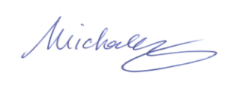

**Michael Megna**

Mayor